Cubital fossa
Etymology: cubita- elbow
A triangular fossa related to front of elbow is cubital fossa
Corresponding to popliteal fossa in relation to knee joint

Boundaries
- Medially – lateral border of pronator teres
- Laterally – medial border of brachioradialis
- Proximally – elbow line – joining two epicondyles

Roof:
- Skin
- Superficial fascia embedded with
- Cephalic vein, basilic vein and medial cubital vein
- Medial and lateral cutaneous nerves of forearm
- Deep fascia with bicipital aponeurosis (extension from tendon of biceps brachii)
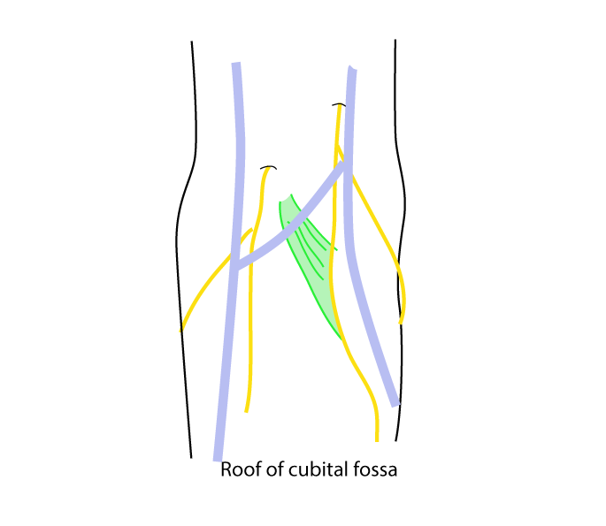
[TIP] Learn to draw the diagram
[YOUTUBE] https://www.youtube.com/watch?v=38MwCVF8a-o

Median cubital vein
Is the venous communication between basilica and cephalic vein
Is the reserve vein for venous access
It is preferred choice of vein for venous access for the following anatomical reasons
- In most people – median cubital vein can be easily identified
- It is superficially located
- It is secured in place by fibrous septae extending from its wall to bicipital aponeurosis – so that the displacement of vessel during venous puncture is minimal

Complications of medial cubital venous access
- Subcutaneous haemorrhage is the most common complication – it may take several weeks to resolve
- Improper knowledge about the anatomy of cubital fossa may lead to injury to tendon of biceps or to median nerve
- Brachial artery may be entered and arterial blood may be drawn;
- Thrombophlebitis and phlebothrombosis

[TIP]Since medial cubital vein is easily identifiable superficial vein – repeated venous puncture must be avoided.

Floor:
- Brachialis tendon
- Supinator muscle
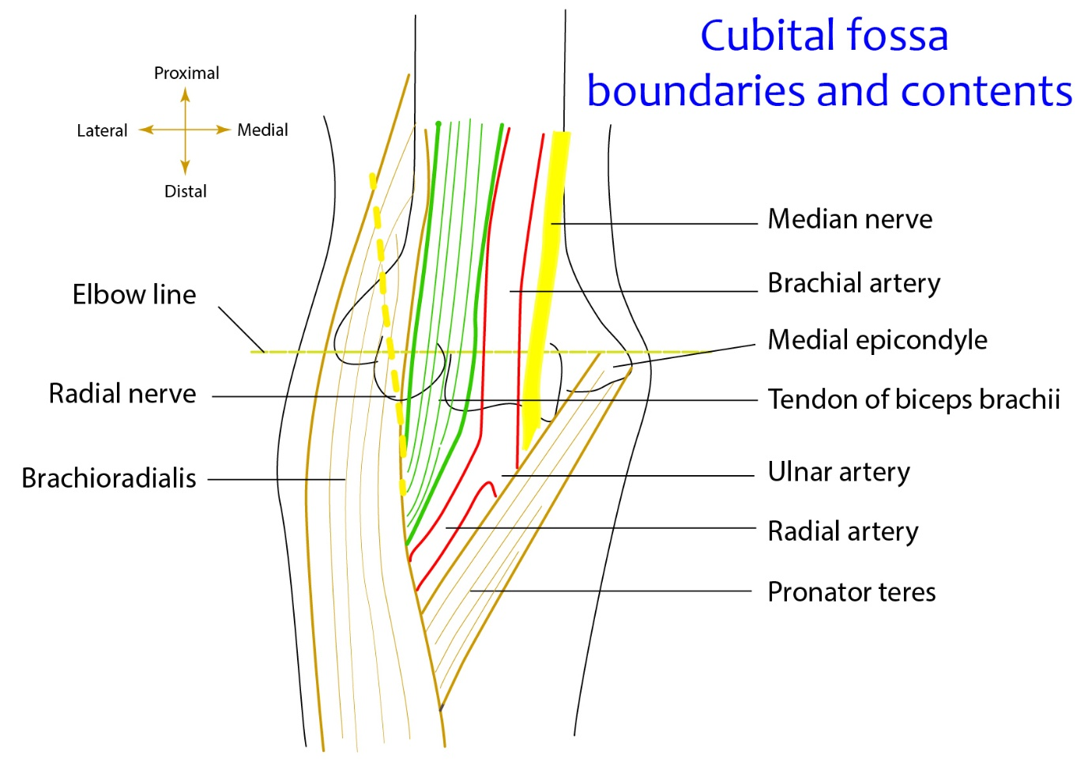

Contents
Medial to laterally
- Medial nerve
- Brachial artery
  - Terminates at the level of radial neck to radial artery and ulnar artery
- Biceps brachii tendon – attached to radial tuberosity posterior part – separated by a bursa
- Radial nerve – in the gap between brachialis and brachioradialis
[TIP]Learn to draw the diagram
[YOUTUBE] https://www.youtube.com/watch?v=2_HQW-AAcww

